- Navigate to https://console.cloud.google.com/marketplace/product/google/container.googleapis.com click the blue button ENABLE
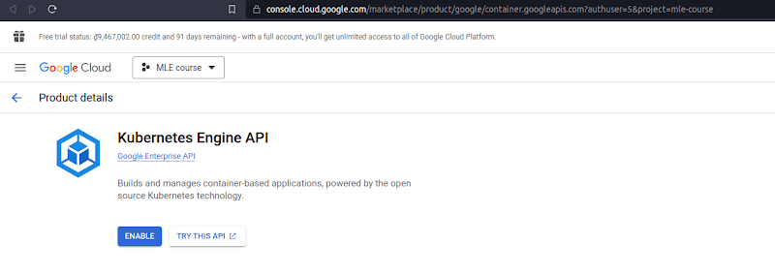
- After waiting for a while, you will be navigated to this page.
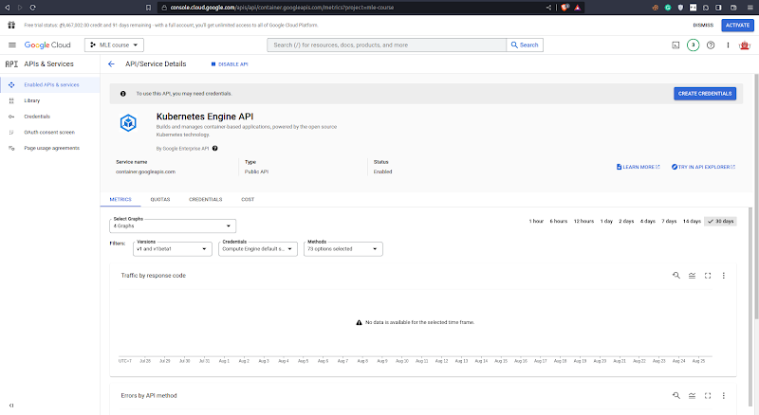
- Access https://console.cloud.google.com/kubernetes. You will see the following page:
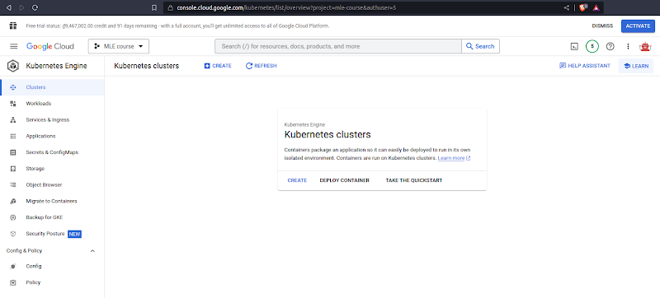
- Hit the button CREATE, and hit LET’S GET STARTED
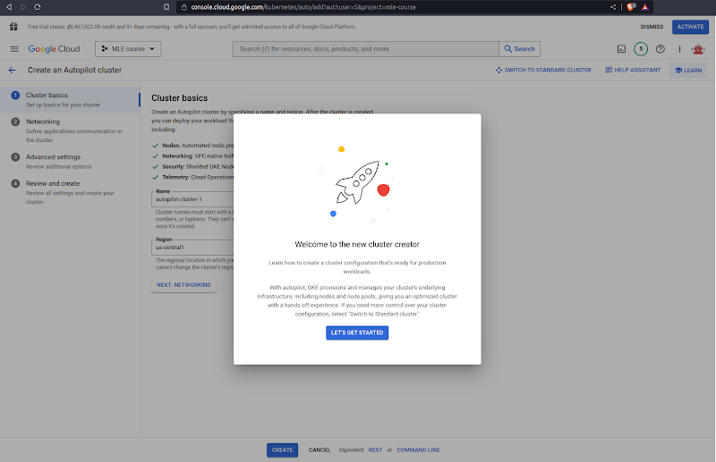
- Click the CREATE button, and wait for about 10 minutes
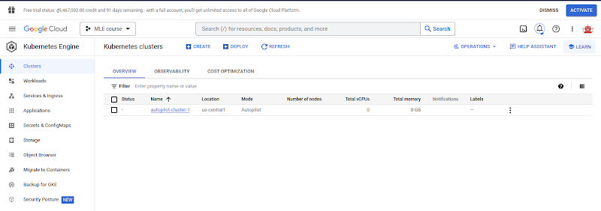
- Now, you can see the cluster has been provisioned successfully!
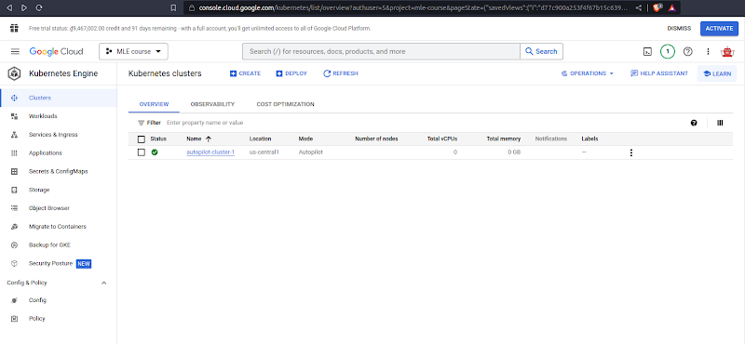
- Click on the cluster autopilot-cluster-1 and select CONNECT
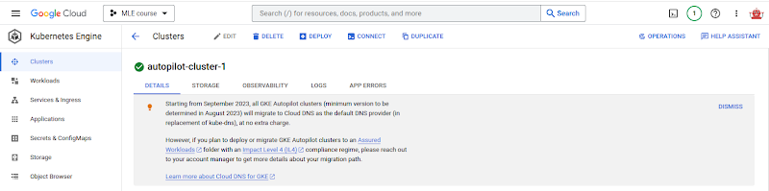
- You will see the popup Connect to the cluster as follows
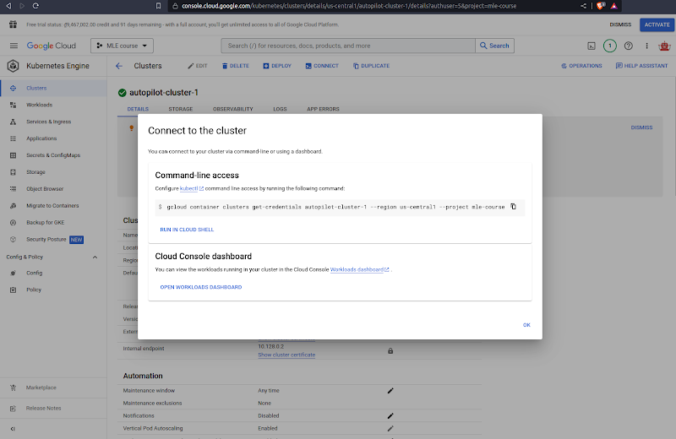
- Copy the line `gcloud container …` into your local terminal as follows
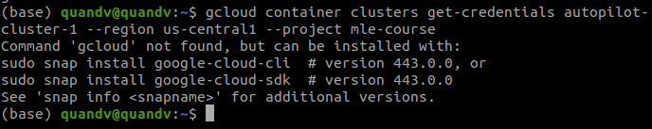
- Well, we haven’t installed gcloud CLI, let’s do it now by following this document
https://cloud.google.com/sdk/docs/install#deb.
- After that, initialize the gcloud CLI by typing `gcloud init`, then type Y
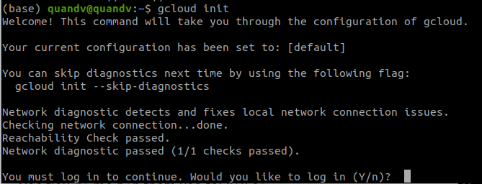
- A pop-up to select your Google account will appear, select the one you used to register GCP, and click the button Allow

- Now, go back to your terminal, in which you typed `gcloud init`, type 1, and Enter
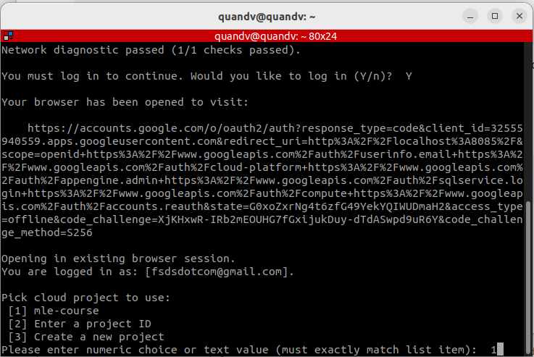
, type Y, and type 8, then Enter.
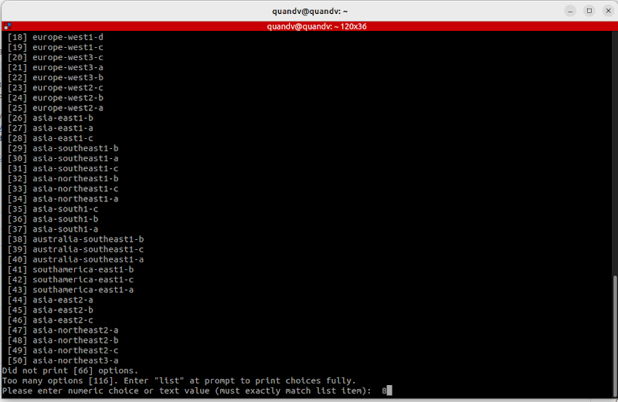
- Now, rerun the command `gcloud container …` in step 8
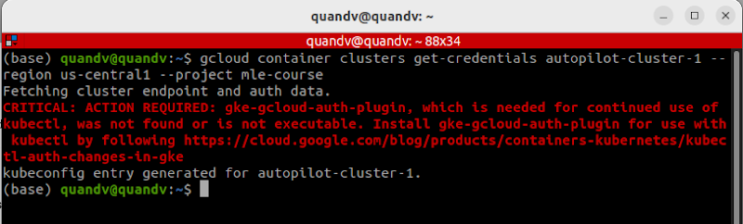
- Now, we need to install gke-cloud-auth-plugin
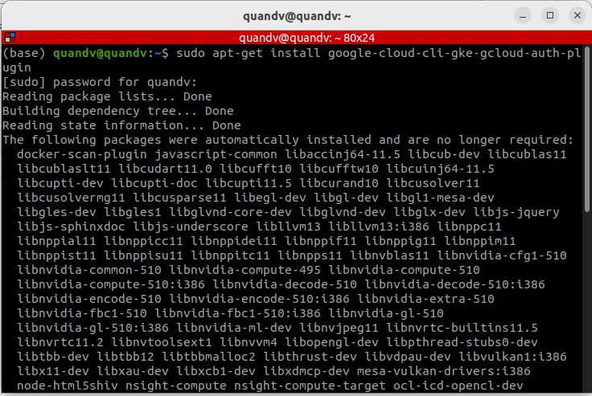
- And...rerun the command `gcloud container …` in step 8
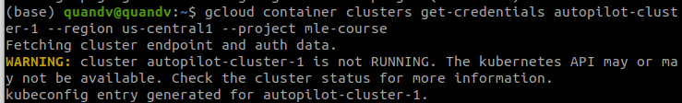
We can see the line `kubeconfig entry generated for autopilot-cluster-1`, that’s good!
- Now, type kubectx in your terminal and select your cluster
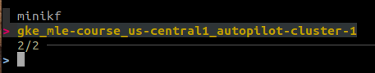
After that, you will see the following result:
- Try getting pods
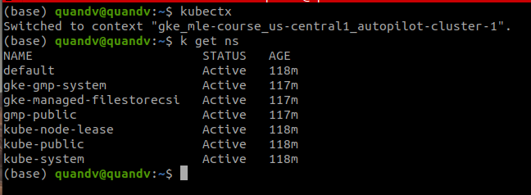
- OK for now. If you want to delete the cluster, navigate back to the tab Clusters, check the cluster box, and hit DELETE
